Lab 13: Graph CLO2,PLO4,P4

Objective(s): Upon completion of this lab session, students will be able to:
Implement Graph, BFS, DFS

Exercise 1: LinkedIn Network of Faculty Members

---------------------------------------------------------------------------------------------------------------------------------------

Consider the given graph as LinkedIn network of faculty members of XYZ University. Your goal is to create a system that allows users to explore direct connections within the network, provides useful insights for collaboration opportunities within the university community.
- Implement the given LinkedIn network of faculty members as a graph using the adjacency list representation.
- Apply BFS traversal starting from a specified user (node) in the network to identify direct connections.
- Calculates and displays the average number of connections per user within the LinkedIn network
- Identifies influential users within the network based on the number of connections they have and their role as bridges between different groups of faculty members.
(Assume >=3 direct link as influential user)

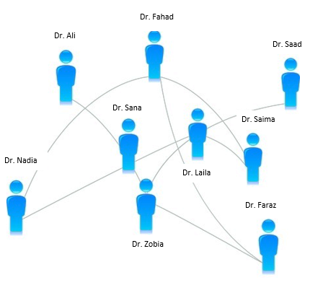
1 Data structure & Algorith
Exercise 2: Course Prerequisite Topological Sorting

---------------------------------------------------------------------------------------------------------------------
Consider the given DAG representing course prerequisite structure for CS program. Apply Topological sort using DFS and Implement a C++ program to show topological order in which courses should be taken to satisfy prerequisites, starting from the Beginner level and progressing to the Advance level.

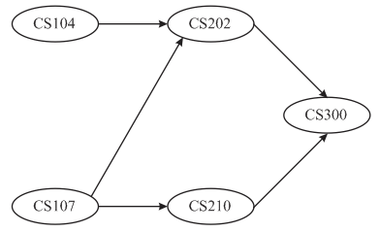

Exercise 3: CodeConnect: Mutual Friends

---------------------------------------------------------------------------------------------------------------------
We are building a social networking platform for a community of developers called CodeConnect. Each developer on the platform is represented as a node in a graph, and friendships between developers are represented as edges connecting the nodes. Your task is to design a C++ code to find mutual friends between two developers.

Let's say you have developers Ashir, Hammad, Sarim, Muneeb, and Izhan in the network. Here's how their friendships are represented:

Ashir is friends with Hammad and Sarim.
Hammad is friends with Ashir, Sarim, and Muneeb.
Sarim is friends with Ashir, Hammad, Muneeb, and Izhan
Muneeb is friends with Hammad, Sarim, and Izhan.
Izhan is friends with Sarim and Muneeb.

